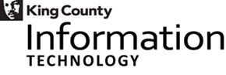

2018 Equity & Social Justice Speaker Series

Anti-Defamation League
Presentation by: Hillary Bernstein and Miri Cypers (Director)

Our mission - For over 70 years, the Anti-Defamation League’s Pacific Northwest Regional Office has provided services and resources dedicated to promoting civil rights and securing fair and just treatment for everyone in our communities. We deliver programs that promote diversity and respect in schools, train law enforcement on hate crimes and bias, advocate for civil rights legislation, and help members of the community handle incidents of discrimination and bias.
Tuesday, August 28th
12:00 pm – 1:00 pm in Chinook Room 123

Brought to you by KC Equity Fund & KCIT ESJ: Learning, Advocating, Cultivating

You are invited!!

